SEPA Direct Debit Mandate  *Unique Mandate Reference  (Will be completed by school and notified to you) | 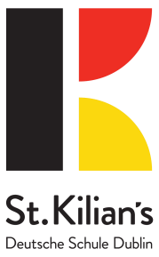
Creditor Identifier: IE69ZZZ300557
Legal Text: By signing this mandate form, you authorise (A) St Kilians German School to send instructions to your bank to debit your account and (B) your bank to debit your account in accordance with the instruction from St Kilians German School.
As part of your rights, you are entitled to a refund from your bank under the terms and conditions of your agreement with your bank. A refund must be claimed within 8 weeks starting from the date on which you account was debited. Your rights are explained in a statement that you can obtain from your bank.
Please complete all the fields below marked *
_____________________________________________
*Your Name :

Address Line 1________________________________________
Address Line 2________________________________________
Your Address:

*City/postcode __________________ * Country:
_________________________
* Account number(IBAN)
*Swift BIC

Please complete and return to:

Creditors Name: St Kilian’s German School
Creditors Address Line 1: Roebuck Road
Address Line 2: Clonskeagh, Dublin 14
Country: Ireland

*Type of payment Recurrent or One-Off Payment (Please tick √)

*Date of signing:

*Signature(s)

